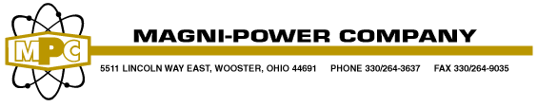

Full Service Metal Fabrication and Stamping
Shear (1/4” x 10’) CNC Punch (30 ton)
Form (230 ton, 12’ long) LASER (5’ x 10’)
Weld (Mig, Tig, Robotic) Punch Press (250 ton, 3’ x 5’)
Spotwelding Powder Coat Paint (2’ x 4’ x 12’)
Assembly Custom Packaging and Kitting

Panels, Bay Frames, Covers, Skids, Boxes,
Brackets, Gussets, Cabinets, Cable Racks, Supports, Enclosures, Housings

- Established business serving industries since 1948
- Located in Ohio with 90,000 sq. footage on 40 plus acres
- Over 100 employees with annual sales over $18 million
- In-house powder coating line for increased flexibility
- Steel processing through .375” thick
- Stainless steel processing through .250” thick
- Aluminum processing through .250” thick
- Pro-E CAD for easy drawing/model communications
- EDI, custom bar-coding, custom labeling to your specifications
- ISO 9001:2015
- Minority Business Enterprise

Serving JIT to the Heavy Truck Market
- Daily order fulfillment utilizing returnable packaging with 48 hour lead-time

Design modification for manufacturing efficiency
- $1.5 million in annual savings on single product line for major truck manufacturer

Financially strong with No Debt allowing quick capital investments/expansions
Example:
- Absorbed $3 million distribution project including purchasing, warehousing, kitting and distribution
for customer during their computer system upgrade transparent to their end customers

Long term partnerships
- Customer relationships in excess of 45 years
- Decades of experience with fortune 100 companies

